Lab Assignment 6
Name: Atharvanath Jha
Roll no. 38, Sec A

Question1:
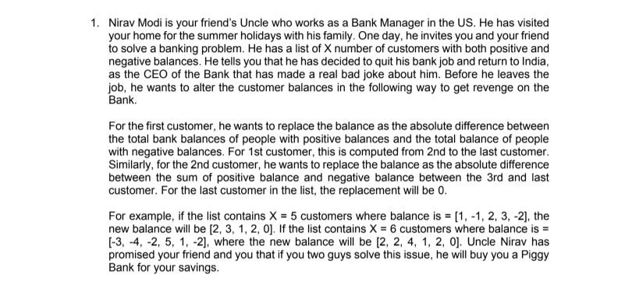
#include <stdio.h>
#include <stdlib.h>

int main()
{
int n;

printf("Enter number of customers: ");
scanf("%d", &n);

int balance[n];
int result[n];

printf("Enter the balances:\n");

for (int i = 0; i < n; i++)
{
scanf("%d", &balance[i]);
}

int positive = 0;
int negative = 0;

for (int i = 0; i < n; i++)
{
if (balance[i] > 0)
{
positive += balance[i];
}
else if (balance[i] < 0)
{
negative += -balance[i];
}
}

for (int i = 0; i < n; i++)
{
if (balance[i] > 0)
{
positive -= balance[i];
}
else if (balance[i] < 0)
{
negative -= -balance[i];
}

result[i] = abs(positive - negative);
}

printf("\nNew balances:\n");

for (int i = 0; i < n; i++)
{
printf("%d ", result[i]);
}

printf("\n");

return 0;
}

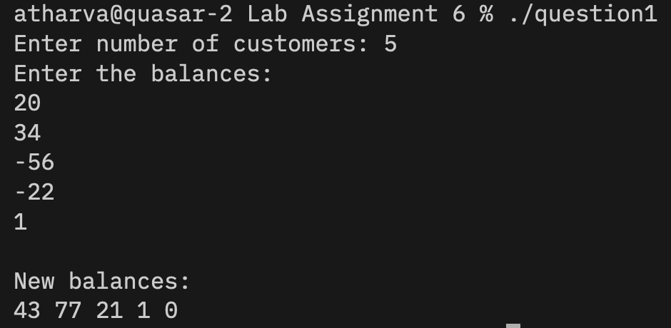
Question2:
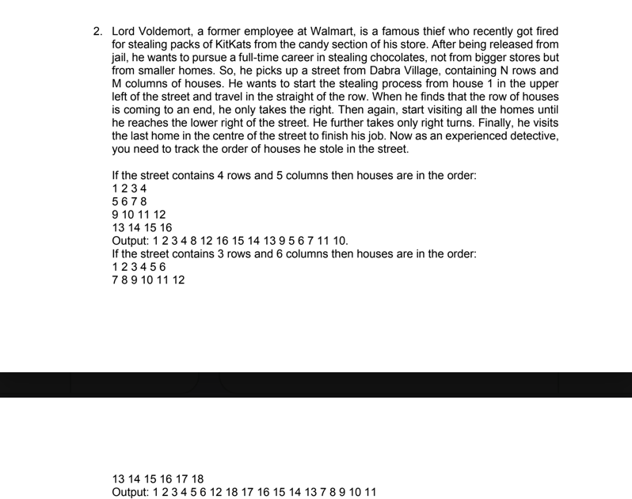

#include <stdio.h>

int main()
{
int rows, cols;

printf("Enter number of rows: ");
scanf("%d", &rows);

printf("Enter number of columns: ");
scanf("%d", &cols);

int matrix[rows][cols];

printf("Enter the matrix elements:\n");

for (int i = 0; i < rows; i++)
{
for (int j = 0; j < cols; j++)
{
scanf("%d", &matrix[i][j]);
}
}

int top = 0;
int bottom = rows - 1;
int left = 0;
int right = cols - 1;

printf("\nSpiral order:\n");

while (top <= bottom && left <= right)
{

for (int j = left; j <= right; j++)
{
printf("%d ", matrix[top][j]);
}

top++;

for (int i = top; i <= bottom; i++)
{
printf("%d ", matrix[i][right]);
}

right--;

if (top <= bottom)
{
for (int j = right; j >= left; j--)
{
printf("%d ", matrix[bottom][j]);
}

bottom--;
}

if (left <= right)
{
for (int i = bottom; i >= top; i--)
{
printf("%d ", matrix[i][left]);
}

left++;
}
}

printf("\n");

return 0;
}
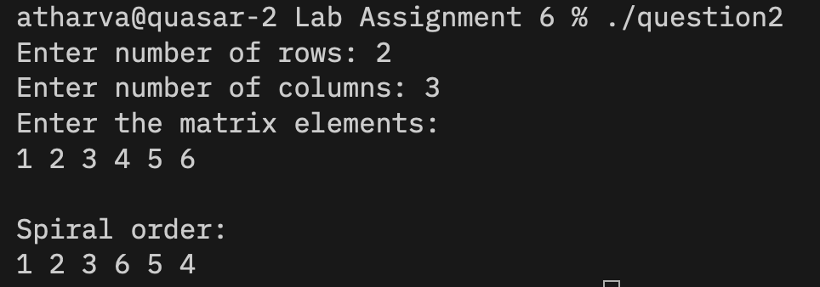

Question3:
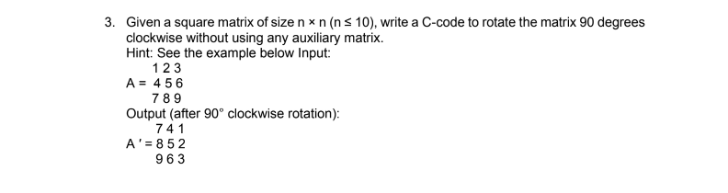
#include <stdio.h>

int main()
{
int n;

printf("Enter size of square matrix: ");
scanf("%d", &n);

int matrix[n][n];

printf("Enter the matrix elements:\n");

for (int i = 0; i < n; i++)
{
for (int j = 0; j < n; j++)
{
scanf("%d", &matrix[i][j]);
}
}

// Step 1: Transpose the matrix
for (int i = 0; i < n; i++)
{
for (int j = i + 1; j < n; j++)
{
int temp = matrix[i][j];
matrix[i][j] = matrix[j][i];
matrix[j][i] = temp;
}
}

// Step 2: Reverse every row
for (int i = 0; i < n; i++)
{
for (int j = 0; j < n / 2; j++)
{
int temp = matrix[i][j];
matrix[i][j] = matrix[i][n - 1 - j];
matrix[i][n - 1 - j] = temp;
}
}

printf("\nMatrix after 90 degree clockwise rotation:\n");

for (int i = 0; i < n; i++)
{
for (int j = 0; j < n; j++)
{
printf("%d ", matrix[i][j]);
}

printf("\n");
}

return 0;
}
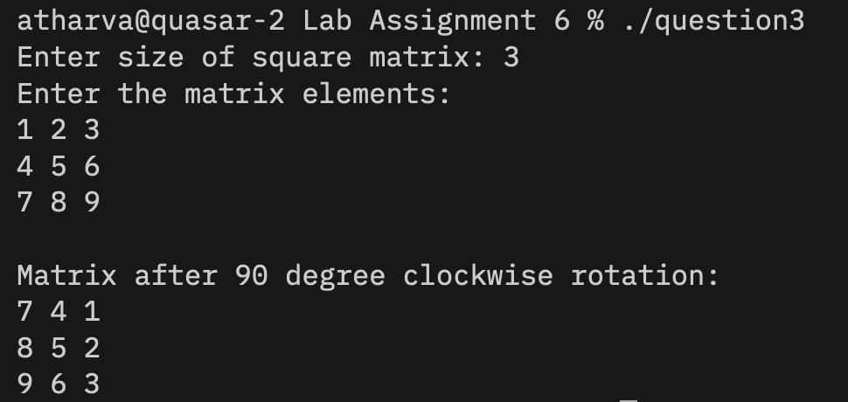

Question 4:

#include <stdio.h>

int main()
{
int rows, cols;

printf("Enter number of rows: ");
scanf("%d", &rows);

printf("Enter number of columns: ");
scanf("%d", &cols);

int matrix[rows][cols];

printf("Enter the matrix elements:\n");

for (int i = 0; i < rows; i++)
{
for (int j = 0; j < cols; j++)
{
scanf("%d", &matrix[i][j]);
}
}

printf("\nBoundary elements:\n");

for (int i = 0; i < rows; i++)
{
for (int j = 0; j < cols; j++)
{
if (i == 0 ||
i == rows - 1 ||
j == 0 ||
j == cols - 1)
{
printf("%d ", matrix[i][j]);
}
}
}

printf("\n");

return 0;
}
